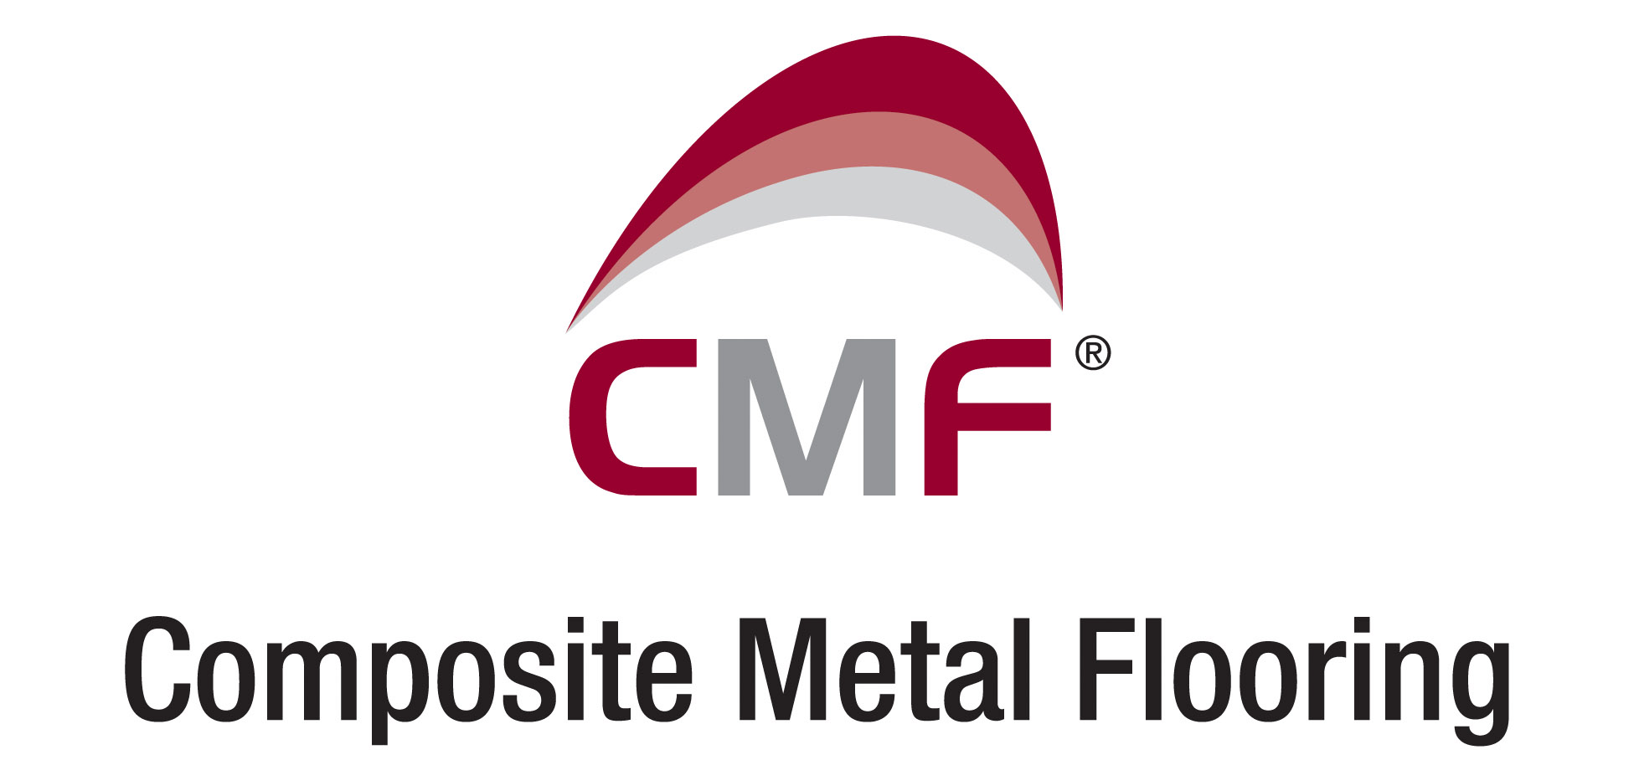

A new generation of Composite Metal Decking profiles designed to take span performance to another level. Fully assessed and verified by the Steel Construction Institute, the Metfloor® range of flooring profiles offer the Structural Engineer total flexibility in composite steel frame design.

Studwelders Composite Floor Decks Ltd and its sister company Northern Steel Decking Ltd have previously established a national distribution network for the design, supply and installation of composite metal flooring.

To offer clients a single point solution, the group has strengthened the product offering by developing a new range of metal flooring profiles manufactured by its wholly owned subsidiary company Composite Metal Flooring Ltd.

The three main profiles, one re-entrant (Metfloor® 55) and two trapezoidal (Metfloor® 60 and 80) were designed by Derek Mullett CEng,MICE,MIMechE, one of the industries’ foremost authorities in the field of Composite steel frame design.

Derek, who joined the group in 2005, brought his strong association with the Steel Construction Institute and Imperial College, London to assist in the development and testing of the profiles.
Fire testing by Pavus A.S in Prague provided the final criteria to be incorporated within the composite design software, written specifically by the Steel Construction Institute.
The embodiment of the Institutes’ logo signifies that Metfloor® products are the only ones that have been fully assessed and verified by the SCI.

The Metfloor® Design software is now incorporated within the Tekla, RAM, CSC, Westok & Fabsec (Software and Solutions for Structural Engineers) product software, allowing the design of a full composite frame solution using Metfloor® profiles.

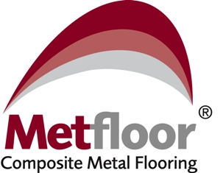
Metfloor® composite metal flooring software and technical literature is available to be downloaded from our Group of Companies website by using the following link www.cmf.uk.com or alternatively a CD Rom and/or Technical Brochure is available upon request.

